Hybrid Energy Storage System MicroGrids Integration For Power Quality Improvement Using Four Leg Three Level NPC Inverter and Second Order Sliding Mode Control

**Abstract**

Rising demand for distributed generation based on Renewable Energy Sources (RES) has led to several issues in the operation of utility grids. The microgrid is a promising solution to solve these problems. A dedicated energy storage system could contribute to a better integration of RES into the microgrid by smoothing the renewable resource’s intermittency, improving the quality of the injected power and enabling additional services like voltage and frequency regulation. However, due to energy/power technological limitations, it is often necessary to use Hybrid Energy Storage Systems (HESS).In this paper, a second order sliding mode controller is proposed for the power flow control of a HESS, using a Four Leg Three Level Neutral Point Clamped (4-Leg 3LNPC) Inverter as the only interface between the RES/HES Sand the microgrid. A three-dimensional space vector modulation and a sequence decomposition based AC side control allows the inverter to work in unbalanced load conditions while maintaining a balanced AC voltage at the point of common coupling. DC current harmonics caused by unbalanced load and the NPC floating middle point voltage, together with the power division limits are carefully addressed in this paper. The effectiveness of the proposed technique for the HESS power flow control is compared to a classical PI control scheme and is prove through simulations and experimentally using a 4 Leg 3LNPCprototype on a test bench.

**EXISTING SYSTEM**

The increasing penetration of DG is changing management of the grid from centralized to decentralized schemes, creating several challenges that must be carefully addressed in order to keep the electrical grid’s proper operation. High penetration of renewable energy can lead to stability and power quality issues due to the stochastic nature of RES, such as wind and solar energy. The microgrid concept, which can be defined as a small scale weak electrical grid that is able to operate both in connected and islanded mode, has been extensively studied as a solution for RES integration. The weak nature of a microgrid implies the use of an Energy Storage System (ESS) to increase RES penetration and insure its stability. The use of an ESS integrates constraints such as admissible bandwidth, maximum ratings, current/power maximum gradient and the number of cycles. If these constraints are not respected it can lead to a dramatic lifetime reduction of the ESS, or in certain cases, to its destruction.

**EXISTING SYSTEM DISADVANTAGE**

* A lack of control of the power flow as well as the ESSs state of charge (soc).
* The use of several DC/DC converters affects the global efficiency
* Limitation with the 3Leg 3L-NPC topology.
* Voltage ripples coupled to highly unbalanced AC loads may cause large DC current harmonics which may increase electromagnetic interference
* Impact ESSs lifetime due to increased thermal losses.

**PROPOSED SYSTEM**

In this paper, the power flow management of a HESS composed of a Li-Ion battery and a Vanadium Redox Battery (VRB) is investigated in a microgrid context. The 4Leg 3LNPC inverter has been chosen to interface the HESS with the microgrid due to its low THD, high efficiency and its ability to manage unbalanced AC loads through the 4th leg. The objective of the paper is to prove that by adding the fourth leg to a 3L-NPC converter and using a new DC side control strategy it is possible to reach both fast and efficient DC power sharing between the two ESSs and the RES, and at the same time improve the AC side power quality. The main contribution of this paper lay in the DC power flow controller which allows HESS power flow control and DC current harmonics suppression. The new model for 4-Leg 3L-NPC structural limits proposed in is asses. The effectiveness of the proposed system has been tested through simulations and experimental tests using a laboratory prototype. The paper is organized as follows: in Section II the ESSs

and 4-Leg 3L -NPC inverter are model. In Section III the design and tuning process of a Second Order Sliding Mode Controller (2-SMC) and a PI classical scheme are developed for the DC power flow control. The AC side control which allows working in unbalance load conditions is also exposed in this section. Section IV features simulations and experiments which aim to prove the effectiveness of the topology and the ability of the 2-SMC to control the HESS

power flow in various conditions.

**BLOCK DIAGRAM**

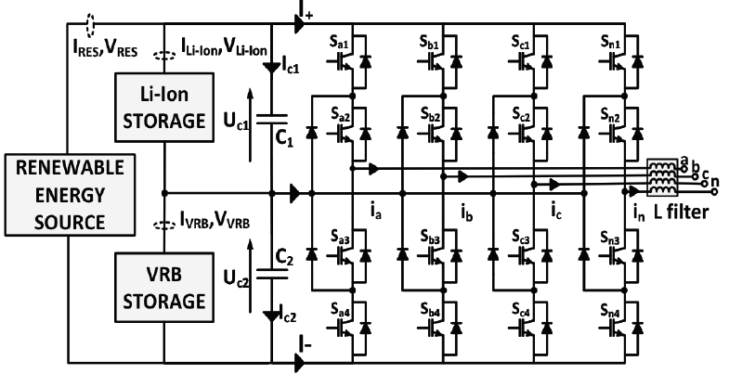

**PROPOSED SYSTEM ADVANTAGE**

* The entire capability of the 4-Leg 3L-NPC converter to insure a maximum power division between the two ESS
* A non-linear 2-SMC scheme has been designed and tuned to control the zero sequence injection in the modulating signals in order to control the power flow of the HESS
* The fourth leg of the converter allows the unbalanced load issue to be addressed, and thus enable active power filter capabilities